**OBJECTIVE**

The objective is to design a brain computing interface which will be specifically designed for the doctors and medical staff to analyse and visualize the reports of the patients based on the data of different brain signals obtained(FMRI,EEG,DTI). Options to download the reports will also be included as well as the usual login/signup activities. A link to open the P300 Speller will also be given. P300 spellers are among the most popular types of brain–computer interfaces (BCIs) and are extremely useful assistive devices that enable severely disabled patients to communicate.

**HARDWARE AND SOFTWARE REQUIREMENTS**

**SOFTWARE REQUIREMENTS**

**Recommended server-side requirements**

|  |  |
| --- | --- |
| Operating System | Windows 7 or above OR Linux,Android 9 or above |
| Web Server | Express |
| Developement Environment | Node.JS |
| Database | PostgreSQL |
| Mobile Server | Express |
| Frontend | HTML,CSS,Javascript,ReactJS |
| Backend | PostgreSQL+Node.JS |
| IDE | VS CODE |

**Recommended client-side requirements**

|  |  |
| --- | --- |
| Operating System | Windows 7 or above, Android 9 or above |
| Browser | Chrome,Firefox,Mozilla,etc |

**HARDWARE REQUIREMENTS**

**Recommended server-side requirements**

|  |  |
| --- | --- |
| Processor | Quad Core or more |
| RAM | Minimum 4GB |
| HDD | Minimum 100GB |
| System Type | Minimum 32-bit operating system |

**Recommended client-side requirements**

|  |  |
| --- | --- |
| Processor | Quad Core or more |
| RAM | Minimum 4GB |
| HDD | Minimum 100GB |
| System Type | Minimum 32-bit operating system |

**Recommended developer-side requirements**

|  |  |
| --- | --- |
| Processor | Quad Core or more |
| RAM | Minimum 4GB |
| HDD | Minimum 100GB |
| System Type | Minimum 32-bit operating system |

1. **FEASIBILITY STUDY**

Financial Feasibility

Being a web based application BCI browser interface will be associated with a hosting cost. The system will follow the freeware software standars.No cost will be charged from the potential customers. BUg fixes and maintaining tasks will have an associated cost.

Technical Feasibility

The main technologies and tools that are associated with the BCI browsing interface are:

HTML

CSS

JS

NODE.JS

REACTJS

PostgreSQL

Each of the technologies are freely available and the technical skills required are manageable.Time limitations of the product development and the ease of implementing using these technologies are synchronized.

Initially the web site will be hosted in a free web hosting space,but for later implementations it will be hosted in a paid web hosting space with sufficient bandwidth.

Hence this project is technically feasible.

1. **PRODUCT FUNCTIONS**

**The main function are:**

1-It is mainly used by the doctors and researchers to analyse and visualize the reports of the patients based on the data of different brain signals obtained.

2-The login page is there that can be only signin by the doctors and the researchers.We will create a check for it.

3-Our main page contains all the information regarding the patient as well as the hospital.(like the hospital name, the patient name, the disease from which he/she is suffering and the patient's complete report). There will be an option to show the complete report of the patient.

4-Options to download the reports will also be included.

5-A link to open the P300 Speller will also be given that will enable severely disabled patients to communicate.

6-An option to show the Visualization of various signals (FMRI,EEG,DTI) will also be provided in our product.

1. **USER INTERFACE**

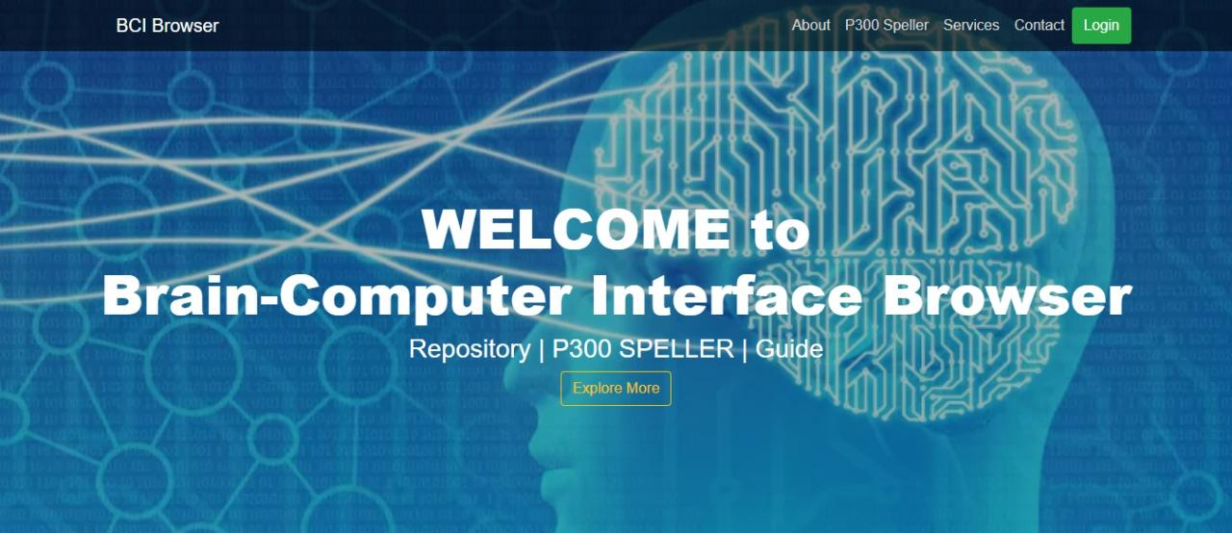

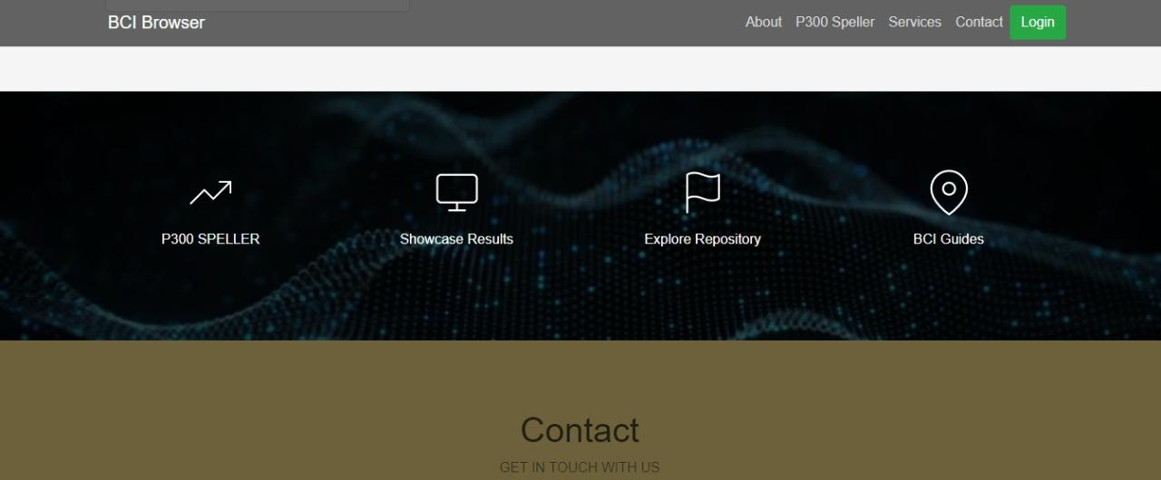

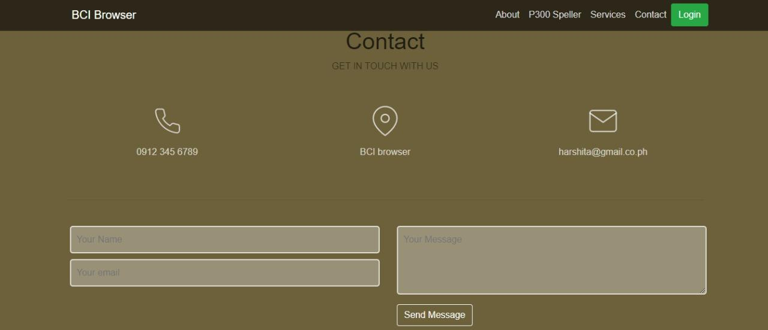

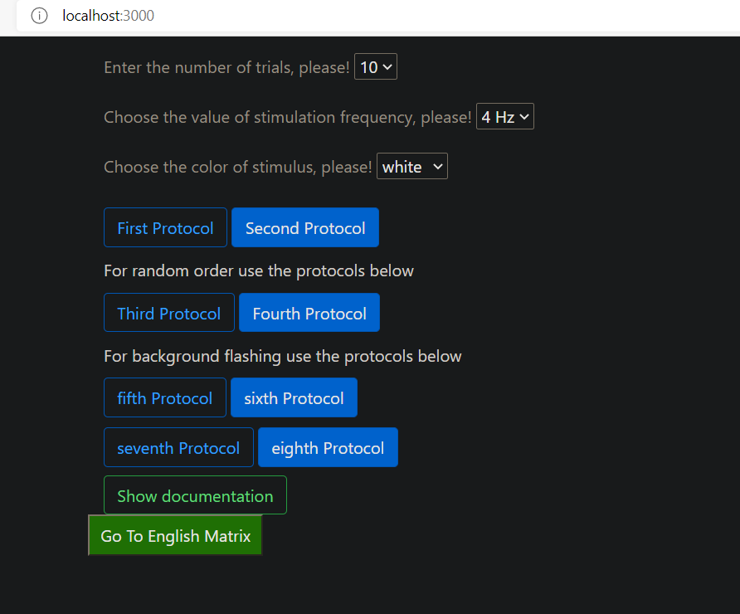

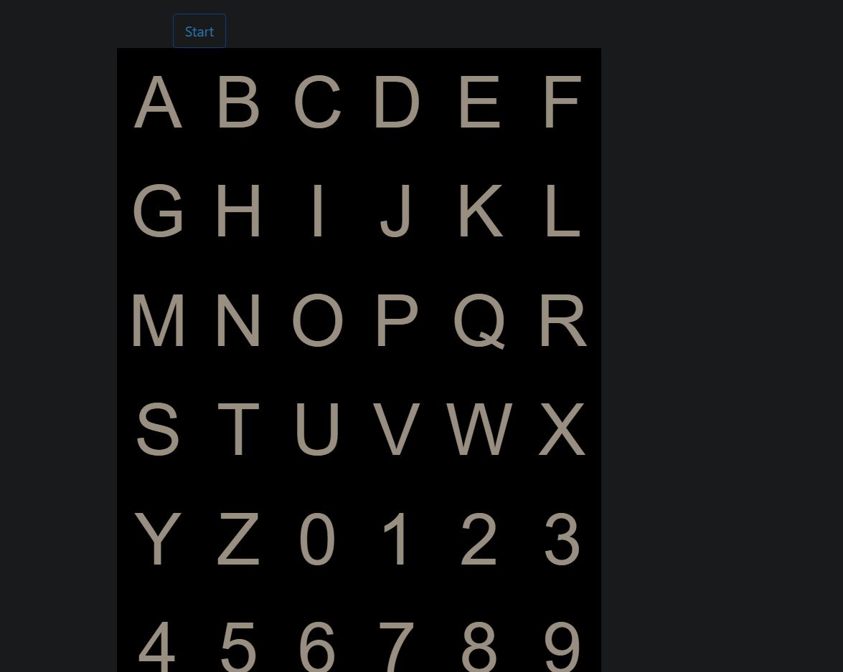

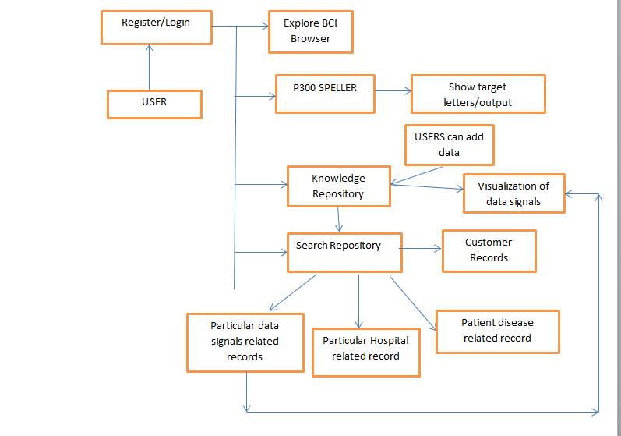

**FIG: APPLICATION INTERFACES**

1. **USE CASE DIAGRAMS**

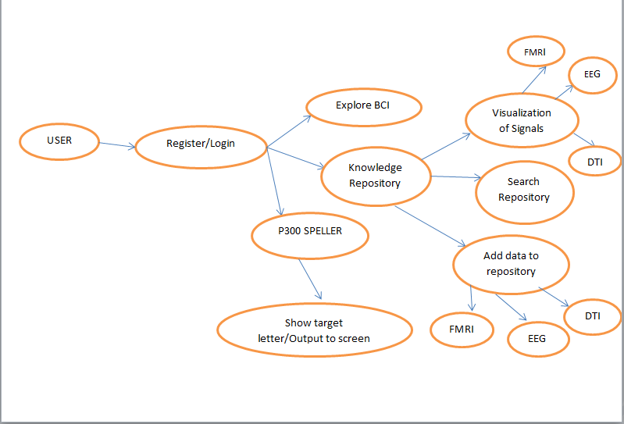

1. **SEQUENCE DIAGRAM**

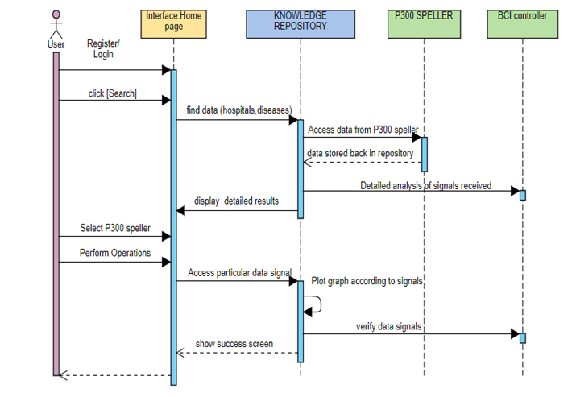

1. **ACTIVITY DIAGRAM**

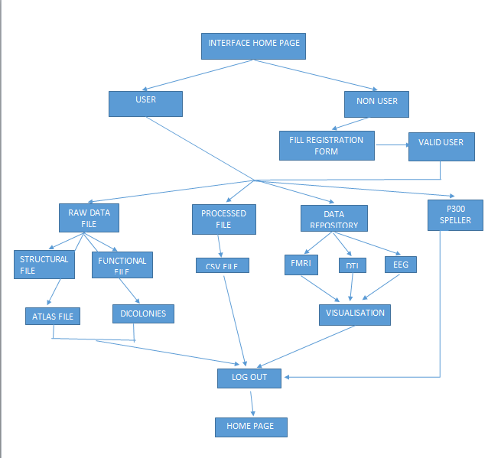

1. **DATA FLOW DIAGRAM**

